Stage 5 – Eunice Kennedy Shriver
Designed by Ryan Christenson
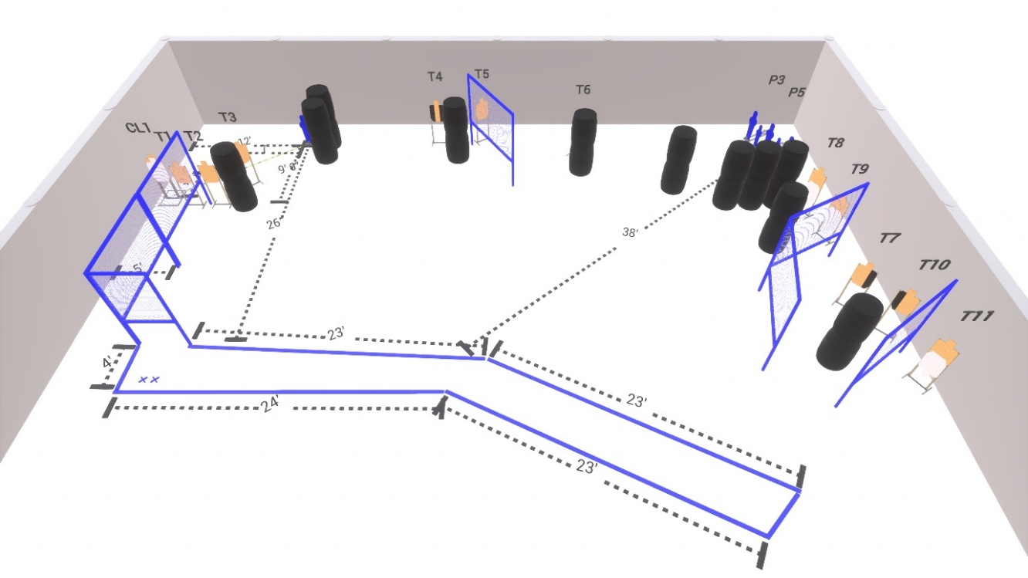
Welcome to Stage 5 - Eunice Kennedy Shriver
Sponsored by Delta Mike Memes.
I am _____________________________, the CRO for this stage and working with me are ____________________________________________________________.
Stage 5 is a 32 round Comstock course with 12 USPSA cardboard targets and 6 steel targets.
Start position is both feet on the Xs.
Handgun loaded and holstered, wrists below belt.
PCC loaded, held in both hands, stock touching belt.
At the audible start signal, engage all targets as available from within the shooting area.
Max Trap is activated by Popper 1 and is not visible at rest.
Are there any questions?
You have 4 minutes to walk the stage.

